**ICP7**

**Case : 1**

Optimizer : RMSPropOptimizer

learning_rate = 0.001  
training_iters = 1000  
display_step = 100  
n_input = 3n_hidden = 512

Average Loss= 1.798062

Average Accuracy= 29.00%

The ouput **loss** and **accuracy** is shown below

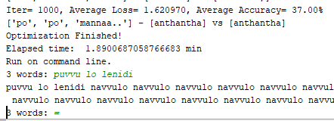

The output graph is shown in the tensorboard.

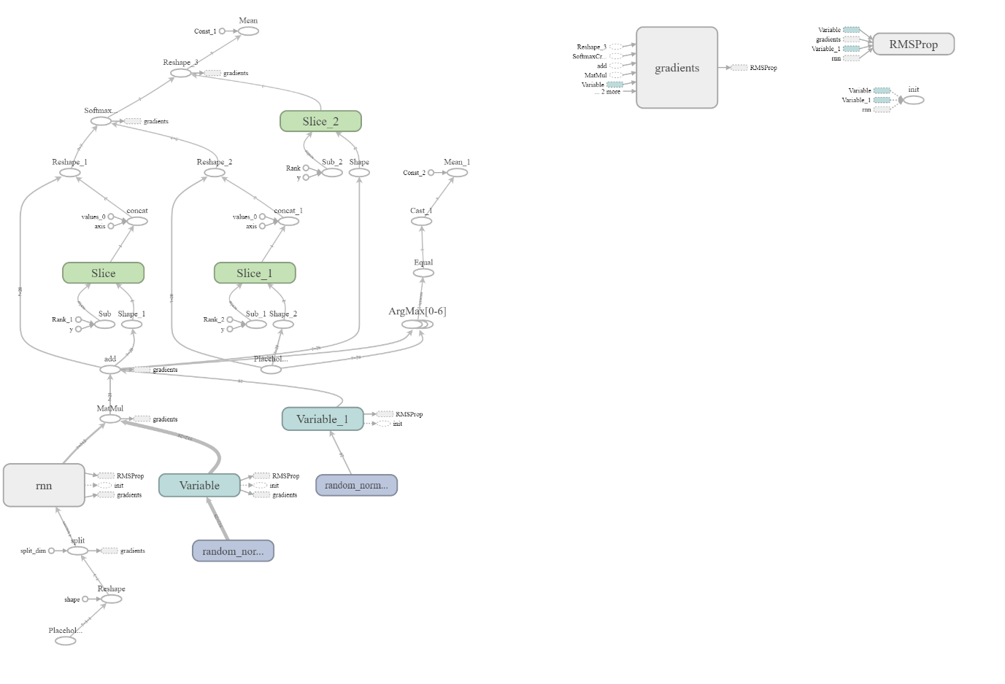

**Accuracy** is plotted in the tensor board.

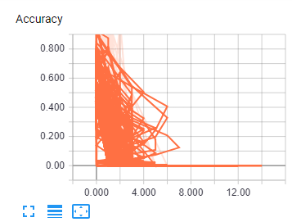

**Loss** is plotted in the tensorboard.

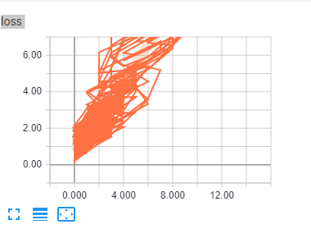

**Case : 2**

Optimizer : AdamOptimizer

learning_rate = 0.1  
training_iters = 1000  
display_step = 100  
n_input = 4n_hidden = 1024

Average Loss= 242.344316

Average Accuracy= 1.00%

The output graph is shown in the tensorboard.

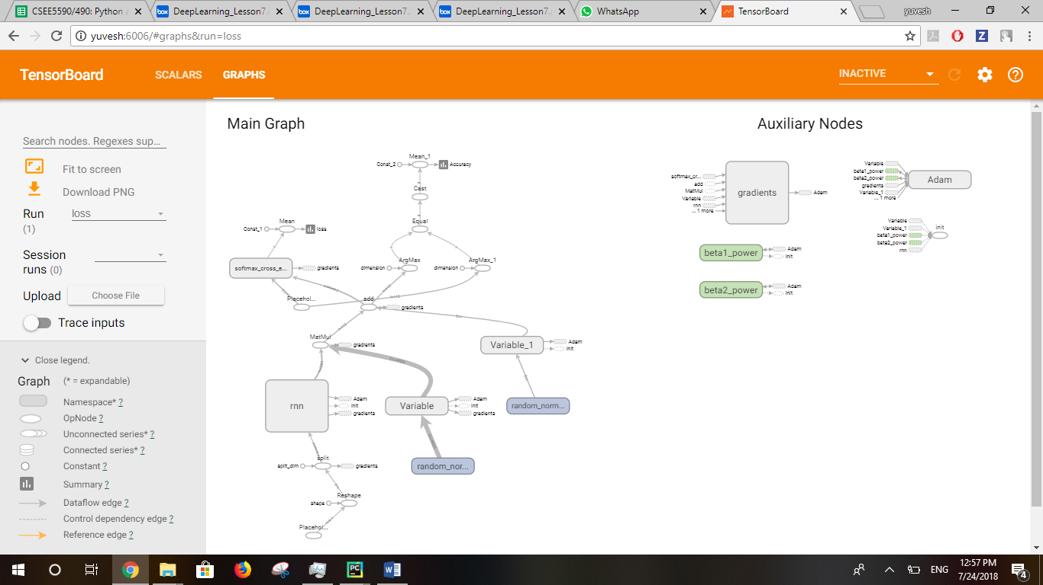

**Accuracy** & **loss** is plotted in the tensor board.

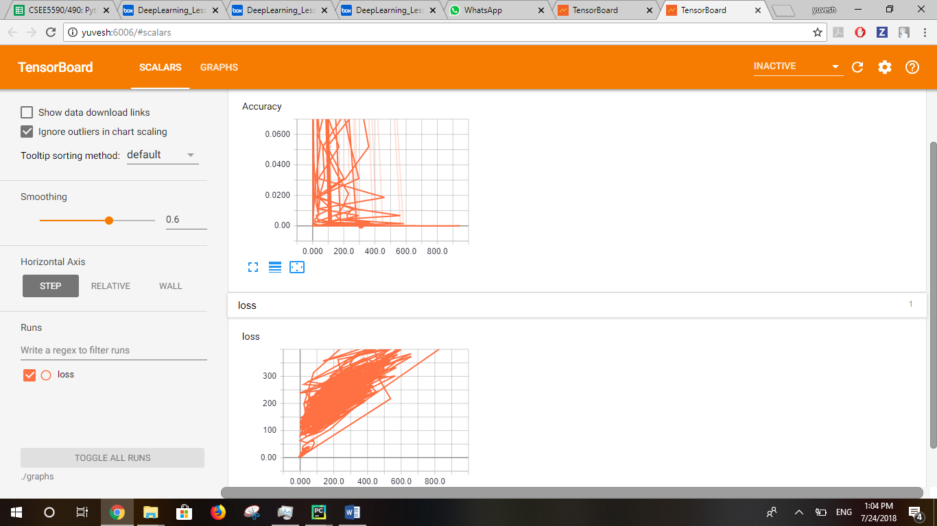

**Case : 3**

Optimizer : RMSPropOptimizer

learning_rate = 0.001  
training_iters = 100  
display_step = 10  
n_input = 3n_hidden = 1024

Average Loss= 5.381041

Average Accuracy= 0.10%

The output graph is shown in the tensorboard.

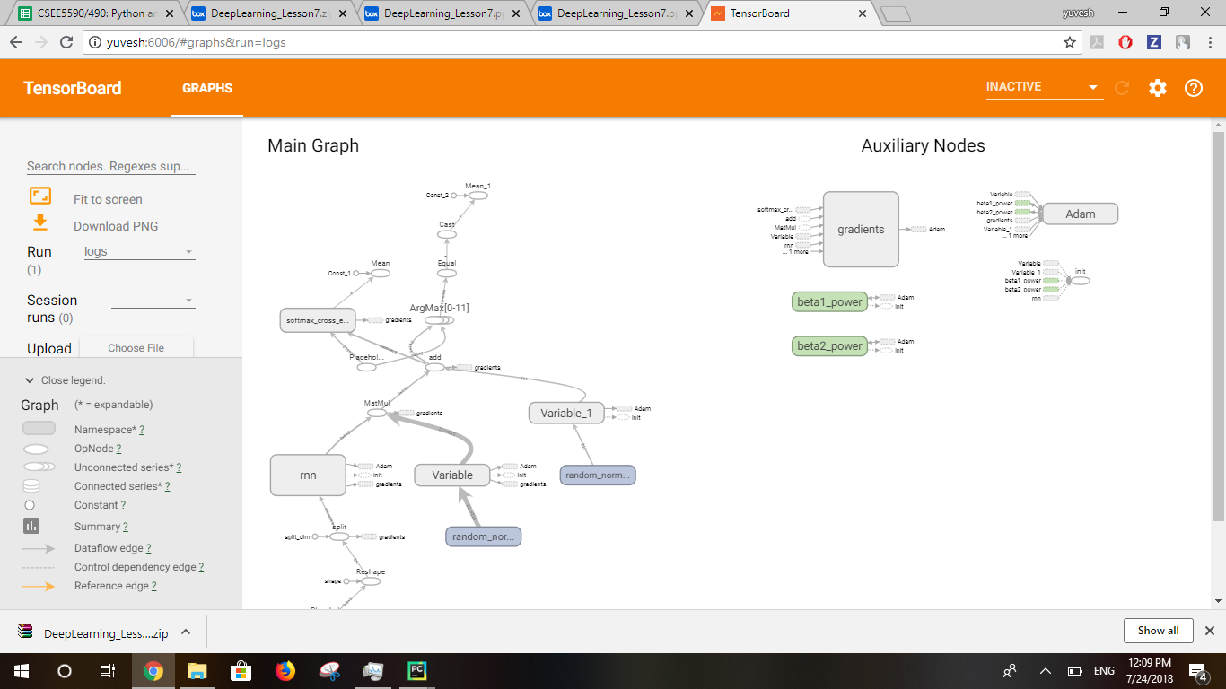

**Accuracy** & **loss** is plotted in the tensor board.

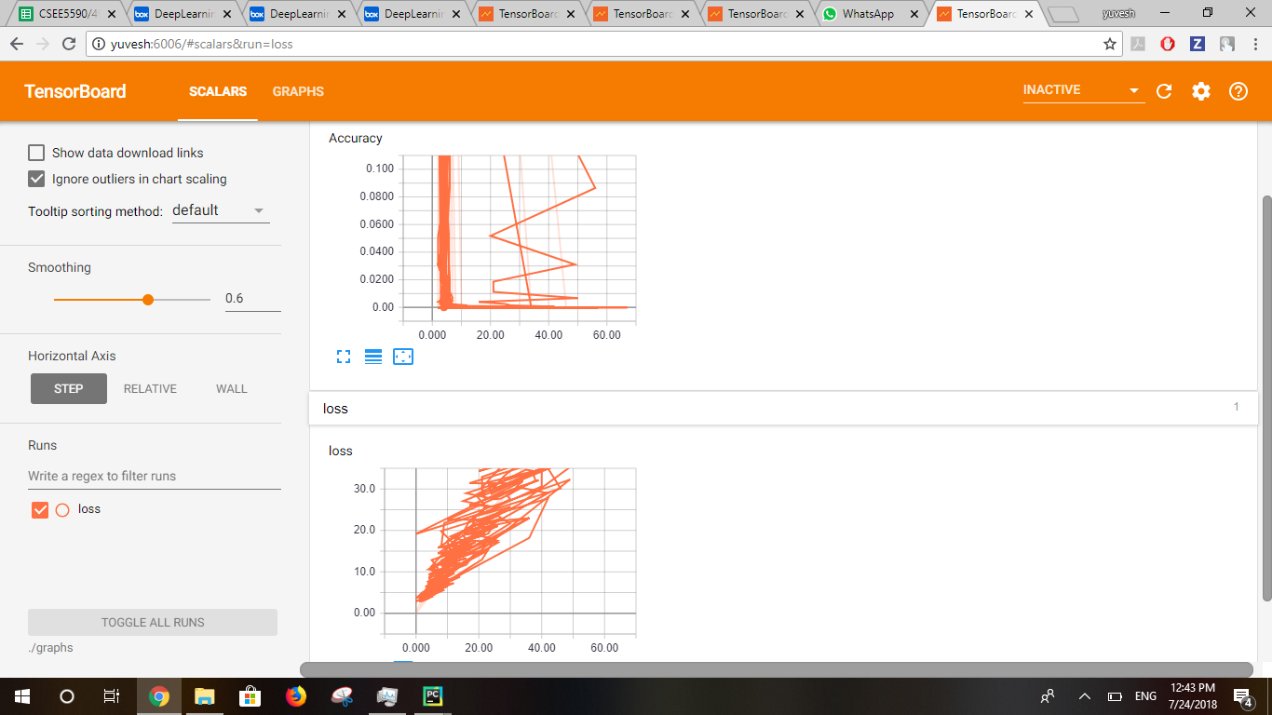

**Observation** :

We got the **better** **accuracy(**29.00%**)**and **less** **loss(**1.798062**)** for the **RMSPropOptimizer** and for the **hyperparameters** listed in **case 1.**